**ASSIGNMENT**

ELECTRICITY BILL MANAGEMENT SYSTEM

a. List the Consumer who have been billed the highest amount during April 2023

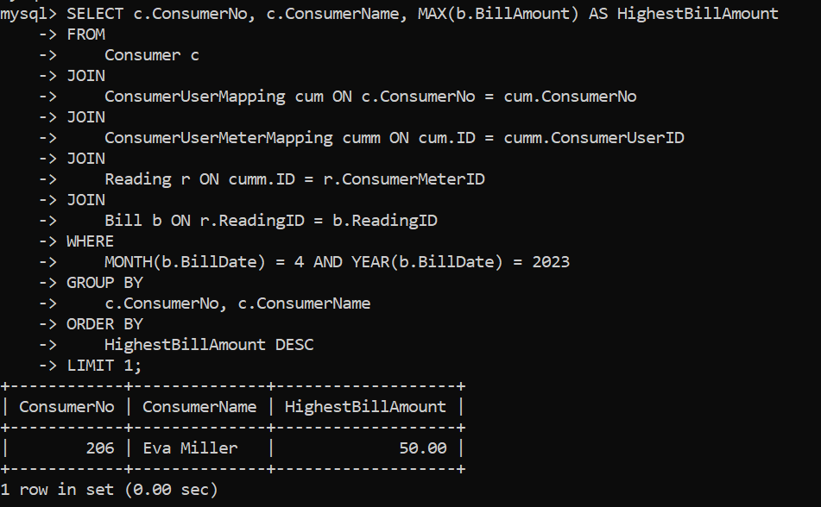

b. Create a report of the bills paid by a particular Customer during 2023 and the amount for each month.

